**Project Code – 16528A**

Forms Automation

Forms Rules Management System- FRMS

495 Functional Specifications

Release 2.0

V3.3

|  |  |
| --- | --- |
| **Project Name / Project Code:** | **LifeWorks/16537** |
| **Business Unit / Program Area (Customer):** | Ind Life Distribution / Ind Life Service Operations |
| **Project Tier:** | Strategic |
| **Project Sponsor:** | Mark McVeigh / Holly Burgess |
| **Project Sponsor Department:** | Ind Life Distribution / Ind Life Service Operations |
| **Project Manager (IT/Business):** | Jason Williams/Charlene Albanese |
| **Project Manager Department (IT/Business):** | Ind Life IT / LifeWorks |
| **Date Submitted:** | 08/25/2015 |

Modification Log

| Version | Revision Date | Changed By | Description of Revision(s) |
| --- | --- | --- | --- |
| v0.1 | 04/05/13 | B. Rickman | Initial draft |
|  |  | B. Rickman | Interim changes that were discarded after Version 3 Changes |
| V0.8 | 04/15/14 |  | Reboot for Version 3 Changes |
| V0.9 | 06/04/14 | Rickman and Geddes | Updates from peer review for IT Review |
| V1.0 | 07/17/14 | Rickman and Geddes | Submitted for V1.0 signoff |
| V1.1 | 01/12/2015 | Rickman | Updates to validations and wireframes, as well as brining in sync through Version 3.2 of FRMS 135 Business Requirements. Also have made updates based on comments from the business. |
| V2.0 | 01/27/2015 | Rickman | Submitted for signoff. |
| V2.1 | 03/11/2015 | Dave,Venkata and Hari | Updates to wireframes with screen shots. |
| V3.0 | 05/27/2015 | FRMS Team | Updated based on review from Alan Henderson.  This version includes comments with corresponding document updates. |
| V3.1 | 07/13/2015 | Hariharan | Updated for database model changes and breakout sessions. |
| V3.2 | 08/20/2015 | Hariharan | Updated based on review from Rick Decost. |
| V3.3 | 08/25/2015 | Hariharan | Updated based on review comments from Aimee. |

Table of Contents

Overview 5

Out of Scope 5

Assumptions 5

Supporting Documents 6

Common Functionality 6

Outstanding Issues 6

Glossary of Terms 6

495: SCREEN FUNTIONAL SPECIFICATIONS 8

1. Common Screen Specifications 8

2. Create/Modify Form 14

2.1 Create Form 15

2.2 Modify Form 20

3. Create/Modify Record 22

3.1 Create Record 23

3.2 Modify Record 26

4. Create/Modify Package 28

4.1 Create Package 29

4.2 Modify Package 32

5. Create/Modify Forms Module Entry 39

5.1 Create Forms Module Entry 39

5.2 Modify Forms Module Entry 42

6. Promotion 44

6.1 Create Release Group 45

6.2 Modify Release Group 46

7. Appendix 53

# Overview

Today the Compliance group within the Life Company maintains an Excel tool that contains the Life Document rules. This tool is in Excel which only one Life resource is maintaining and upgrading. With the project of LifeWorks, the Compliance manager has requested that this tool be maintained by IT in the go forward LifeWorks solution.

The Forms Rules Management System (FRMS) is replacing the current Compliance Excel tool (see Appendix B for an extract), ‘The Formulator’, which today is used to manage the Life and Annuity Insurance products Document rules in conjunction with the Forms Module. The Forms Module will not be replaced in the go forward solution but will integrate with the FRMS to obtain the document rules for existing legacy systems that will still utilize the Document rules for products that have not migrated and for certain business processes maintained in the legacy systems.

The FRMS will be a multi-purpose system which will allow for Compliance to carry over needed business functionality that it has today in Formulator for everyday queries and maintaining the Life Document rules. This FRMS will hold another purpose to integrate with the external systems to provide the listings of document, indexing categories and classifications, and integrate with the current Forms Module to provide document rules.

# Out of Scope

The items listed below are out of scope for Release 2.0 but may be considered for a future release

1. Systematic Loading of correspondence templates and inactive product Document templates into the FRMS
2. Automation of the Document filing process development life cycle within the FRMS
3. Ability to add Adhoc fields to the FRMS
4. Product Documents and Correspondence managed in the FRMS
5. Automated Assignment of Document Number within the FRMS
6. Integration directly from FRMS to Documaker to create blank forms.
7. Plan Code for Vantage will not be added to the FRMS.
8. Meta-data Administration will not be managed by FRMS, but rather through RDM
9. User Adminstration (Add/Modify/View User, Add/Remove Permission, Archive/Restore user)
10. Uploading and Viewing a Form (Document Templates)
11. Query and Export

# Assumptions

1. Promoting generated Release Group files to specific environment is a manual process that must be scheduled through release group manager.
2. Forms Extract will be validated for accuracy prior to the load into FRMS.
3. Forms Module Extract will be validated for accuracy prior to the load into FRMS.
4. Searching/Exporting/Reporting will not negatively affect performance during core business hours (See NFR Section)

# Supporting Documents

**Forms Rules Management System 135 Business Requirements:**

<http://pmecollaborate/it/ilh/BAPGRM/Realease%202/R2_I6_135_FRMS%20v3.3.docx>

**Unique Forms Spreadsheet (CR 409) - Classification and Sub-classification Document:**

<http://pmecollaborate/it/ilh/BAPGRM/Realease%202/FRMS%20-%20Unique%20Forms.xlsx>

**Presentation Services Wiki:**

<https://wiki.lmig.com/display/pmitlife/Presentation+Services+-+FRMS>

Standard Dojo Widgets:

<http://pmecollaborate/it/ilh/BAPGRM/Realease%202/Standard_Dojo_Widgets.docx>

**High Level Technical Document (IDD) for all non-UI based functionality:**

<http://pmecollaborate/it/ilh/BAPGRM/Realease%202/IDD_FRMS_R2It6.docx>

# Common Functionality

1. Create screens shall be the default for each tab on Main Navigation.
2. Modify screens shall have search functionality to Modify a Form/Record/Package/Forms Module entry.

# Outstanding Issues

Please refer to the issues related to FRMS in the LifeWorks Questions Log located in SharePoint

# Glossary of Terms

Abbreviations in this document:

|  |  |
| --- | --- |
| ANSC | Alpha-Numeric Special Characters |
| M | Mandatory |
| CM | Conditional Mandatory |
| O | Optional |
| AP | Auto Populated |
| E | Editable |
| NE | Not Editable |
| In-Progress Release Group | Release Group with Pending, Scheduled, Installed (Dev, QA etc except Production) Status. |

Please refer to the Lifework’s Program Glossary of Terms in SharePoint

<http://pmecollaborate/it/ilh/BAPGRM/Common/LifeWorks_Glossary_of_Terms.xlsx>

# 495: SCREEN FUNTIONAL SPECIFICATIONS

# Common Screen Specifications

* 1. The system shall determine if required data has been entered when attempting a Save.
     1. If data required to perform a save is not entered the following alert message shall display: “Required data has not been entered.”

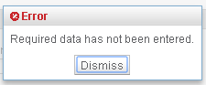  
 Fig 1.a Required data has not been entered alert

* + - 1. Required data elements that have not been entered shall be visually distinguishable. (e.g. how ePass displays icons next to required fields) 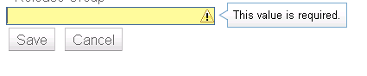  
          Fig 1.b value is required alert
    1. The following data shall be captured when new entries are saved:

| **Data Element** | **Auto Populate** | **Format/Valid Values** | **Default** |
| --- | --- | --- | --- |
| Created Date | Yes | Format:  mm/dd/yyyy hh:mm | Date/Time Saved |
| N# | Yes | n9999999 | User logged In |



* 1. The system shall capture the following information when a Comment is entered:

| **Data Element** | **Required** | **Editable** | **Field Type** | **Length** | **Format/ Values** |
| --- | --- | --- | --- | --- | --- |
| Created Date | AP | NE | Date/Time | - | Format:  mm/dd/yyyy hh:mm |
| Comments | M | E | Memo | 1000 | Length :1000 Format:  Free form text - ANSC |
| N# | AP | NE | AN | 8 | n9999999 |

* 1. The system shall display the following information when displaying a Comment:

| **Data Element** | **Required** | **Field Type** | **Format/ Values** |
| --- | --- | --- | --- |
| Created Date | AP | Date/Time | Date/Time Saved Format:  mm/dd/yyyy hh:mm |
| Created By: Last Name | AP | ANSC | Format:  Last Name |
| First Name | AP | ANSC | Format:  First Name |
| N# | AP | AN | n9999999 |
| Comments | AP | Memo | Length:1000 Format:  Free Form Text |

* 1. The system shall provide the ability to sort each column in a list ascending and descending order.
  2. The system shall provide the ability to enter dates in multiple formats (Note: This does not apply to the Revision Date format) (CR 409):
     1. m/d/yy
     2. mm/dd/yy
     3. mm/dd/yyyy
        1. The system shall transform the entered date into the following format:
           1. mm/dd/yyyy
  3. When any field level validation in FRMS fails, the field will visually indicate the error as noted in section 1.1.1.1 or the corresponding label changing to a bold, red font. Basic hover text giving further detail will be displayed as appropriate below:
     1. For required fields, if no value is entered: “This value is required”
     2. For alpha-numeric (AN) only fields, if invalid characters are entered: “Only alpha-numeric characters are allowed”
     3. For numeric only fields, if invalid characters are entered: “Only numeric characters are allowed”
  4. For maximum length of fields, the UI will prevent the user from entering more characters than is allowed. There is no need for additional messaging, as the user is prevented from entering text that is too long.
  5. Products Screen
     1. This screen is used to select product name(s) for Create/Modify Forms/Records modules.
     2. The values are populated from RDM using Product Service. Any changes to the external product list shall be automatically available in FRMS Products Screen.
     3. All sections in this screen are used as filter criteria for Product name(s). The exception being if no values are selected from a given group, it mean that group is not used in the filter criteria (the same as having all selected for that group). Selecting any of the checkbox values in Line of Business, Product Type, Product Series Name, Product CSO Mortality Type, Product Sub Type and Product Marketing Name will refresh and show product names in Excluded box related to the selection.
     4. Select product name from Excluded box and Clicking “Include” button shall include the product name to Included box.
     5. Select product name from Included box and Clicking “Exclude” button shall exclude the product name from Included box.
     6. Clicking “Include All” shall include everything to Included box.
     7. Clicking “Exclude All” shall exclude all Product names from Included box and included in Excluded box.
     8. Clicking Save button shall return the user to Forms screen with Included box product name(s) to Rules section.
     9. Clicking Cancel will invoke Unsaved Changes functionality (Sec 1.9 Unsaved Changes) and does not cancel the Create Form that is in progress.

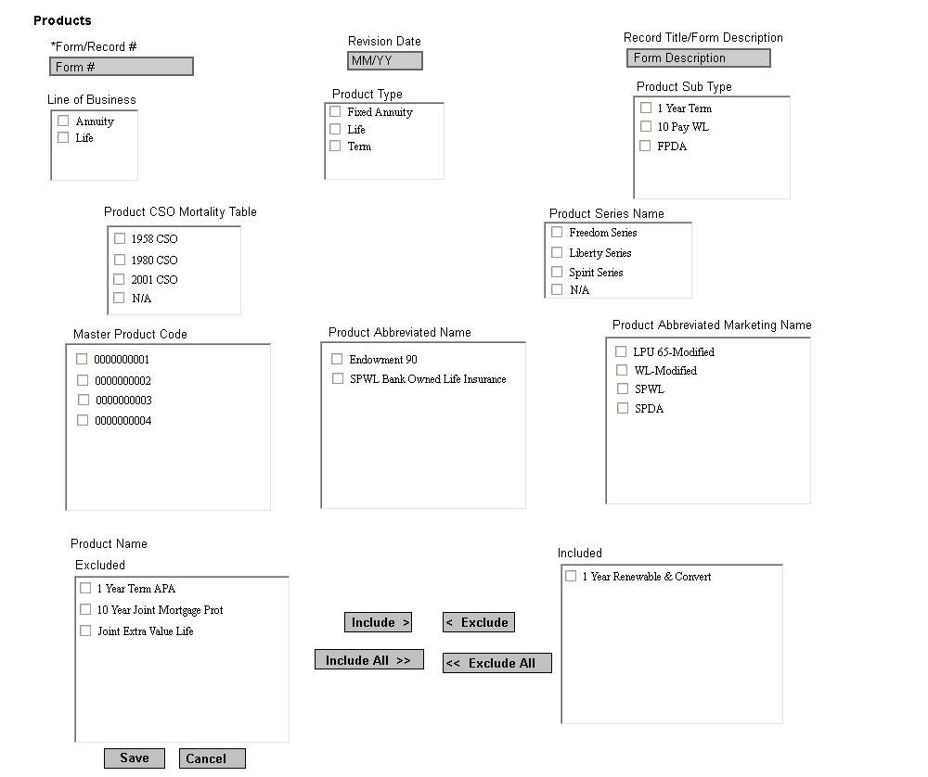

Fig : 1.c – Products Screen

Product Screen Fields

| **Screen Label** | **Required For Shell** | **Other Information** | **Required For Promotion** |
| --- | --- | --- | --- |
| Line of Business | O | See: Product Master List | O |
| Product Type | O | See: Product Master List | O |
| Product Sub Type | O | See: Product Master List | O |
| Product CSO Mortality Table | O | See: Product Master List | O |
| Product Series Name | O | See: Product Master List | O |
| Master Product Code | O | See: Product Master List | O |
| Product Abbreviated Name | O | See: Product Master List | O |
| Product Abbreviated Marketing Name | O | See: Product Master List | O |
| Product Name | O | See: Product Master List | M |

* 1. Unsaved Changes
     1. User shall get unsaved changes alert message when clicking on cancel instead of save after they add/update any of the screen values.
     2. Clicking Discard shall not save changes and user will lose any unsaved changes.
     3. Clicking Cancel shall keep the user on the calling screen where they can save the changes and perform any other actions as necessary.

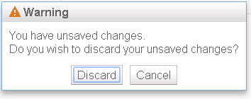  
Fig: 1.d – Unsaved Changes Alert

* 1. View/Add Comments
     1. In the comments screen user shall see the Form/Record #, Revision Date, RIC, Record Title/Form Description and Previous entered comments (Fig 1.e).
     2. User shall see the Form #, Revision Date, RIC, Form Description when the comments screen invoked from Forms Screen.
     3. User shall see the Record #, RIC, Record Title when the comments screen invoked from Records Screen.
     4. User shall see the Package Name, RIC when the comments screen invoked from Package Screen.
     5. Previous Comments shall be displayed in descending order based on Created Date.
     6. User shall enter new comments under Add Comment Section.
     7. Clicking Save shall save the comments and refresh that comment in comments section table.
     8. Clicking Cancel shall invoke Unsaved Changes functionality (Sec 1.9 Unsaved Changes)

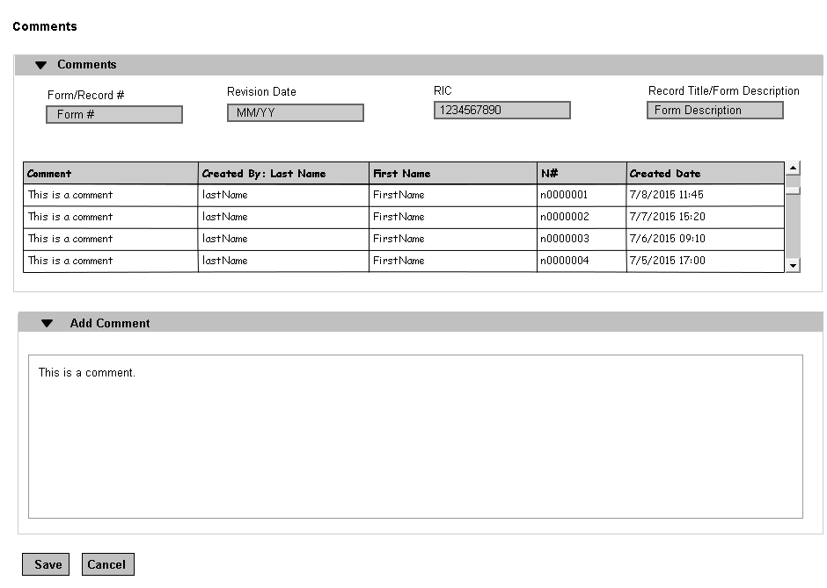   
 Fig 1.e View/Add Comments Screen

* 1. Production Promotion Indicator
     + - 1. Rest service shall not set any promotion indicator value (ie null) to database when user create Form, Record, Package Version and Forms Module Entry.
         2. Rest service shall set Promotion Indicator to 1 when the user check ‘Mark for Promotion’ check box from Create/Modify Form, Create/Modify Record, Modify Package, Create/Modify Forms Module Entry User Interface.
         3. Informatica Job shall set Promotion Indicator to 0 when Release Group successfully promoted to Production system.



















# Create/Modify Form

The main navigation Form tab is where all functions related to Form is performed. From this tab user can create new Form and modify existing Form. (Modify Form link).  
  
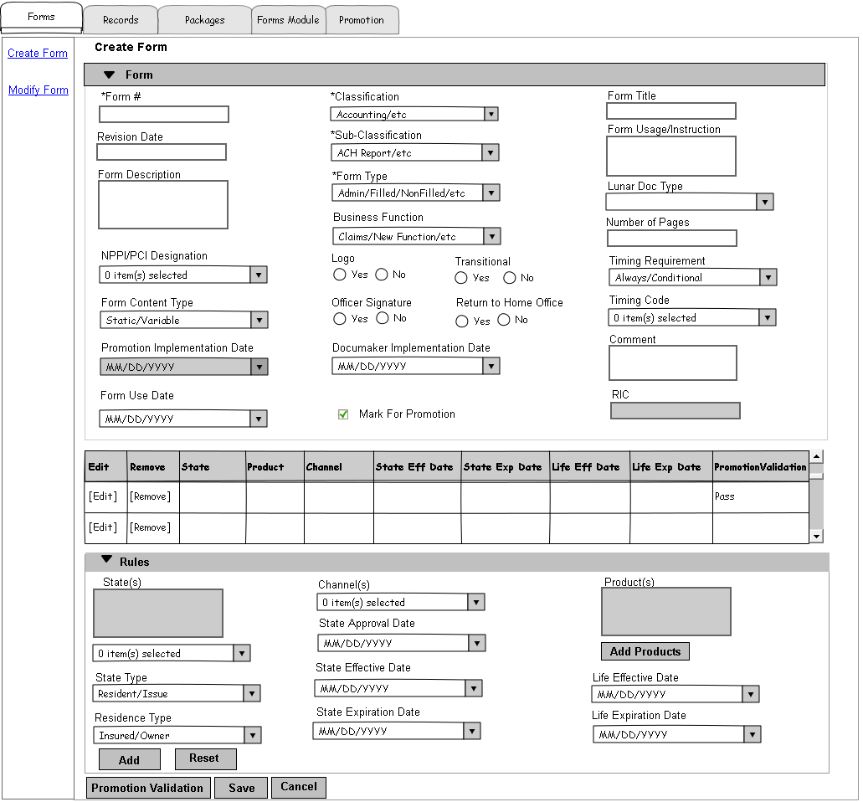  
 Fig: 2.a – Forms Home/Create Form Screen.

## Create Form

* + - 1. Create Form Screen Functionality  
         1. Revision Date shall manually be validated that it follows the format of mm/yy where two numeric digits are required before and after the slash. If an invalid entry is made, the error shall be displayed as “Please enter valid revision date in mm/yy format.
         2. If values are selected from the Classification drop-down, the Sub-Classification values shall be filtered based on the Classification values. If values are selected from the Sub-Classification drop-down prior to choosing values in the Classification drop-down, values in the Classification drop-down shall be filtered based on the Sub-Classification values chosen.
         3. If N/A is selected in NPPI/PCI designation no other options can be selected. If values other than N/A are selected, N/A cannot be selected.
         4. State Approval Date and State Expiration Date shall be disabled if the form type not Filed or Non-Filed.
         5. State Approval Date must be on or before the current date.
         6. Life Effective Date must be on or before the Form Use Date.
         7. Life Expiration Date must be on or after the Life Effective Date (CR641).
         8. State Type shall be required if the Form Type is Filed, Non-Filed, or Admin.
         9. Return to Home Office shall be disabled and default to “No” If the Form Type is not Filed, Non-Filed, or Admin.
         10. Clicking Add Button under Rules section add Form variations to a Form. User shall select multiple State, Product and Channel combinations with other values, but the table above represent them with single State, Product and Channel variation per row. Adding 2 States, 2 Products and 2 Channels represent 6 rows in the table.
         11. Clicking Edit link in table shall bring the variation (State/Product/Channel) to Rules section for any changes. This shall discard any previous values in Rules section.
         12. Clicking Edit link in the table shall disable the Edit link to avoid multiple clicks on the same Edit link. Clicking on Add/Reset button after making any changes to variation in Rules section shall enable the Edit link.
         13. Clicking Remove link in table remove any invalid variation (State/Product/Channel) entered by user for Form before save.
         14. Clicking States drop down allows the user to select multiple states (ctrl + select state checkbox). The total list of states should be 51 US states, including Washington DC. The list of selected states shall be listed in the box above drop down for quick reference.
         15. Clicking Add Products button shall display Products screen and allow user to add Products to the Form. (Fig: 1.c). Please see section 1.8 from Product screen functionality.
         16. Clicking Add button shall populate variation(s) to the last row of the table. Clicking save button shall save the changes permanent in database.
         17. Clicking Reset button shall clear and discard any partially entered values or variation selected.
         18. Clicking the Promotion Validation button shall validate the Form for all mandatory fields that are missing for Promotion (table 2.1.2). If the Form has any partial variation(s) entered then it validate for conditional mandatory fields and indicate Pass/Fail in Table column ‘Promotion Validation’. (i.e. If state/channel is selected but no product selected). By default ‘Promotion Validation’ column in the table shall be empty.
         19. Clicking Save shall run validations against this screen and save Form information if validations pass. If Mandatory fields have not been entered and a Save is attempted, the system shall display the following warning: “The minimum data required to save this Form has not been entered.
         20. If the Form # and Revision Date combination already exists system shall invoke Duplicate Form alert (Please refer section 2.1.3 Duplicate Form.)
         21. Clicking cancel shall invoke Unsaved Changes functionality (Sec 1.9 Unsaved Changes).
         22. Fields denoted with an ‘*’ are required.
      2. Form Screen Fields.

| **Screen Label** | **Required For Shell** | **Other Information** | **Required For Promotion** |
| --- | --- | --- | --- |
| Form Type | M | Single-select Values:   * Filed * Non-Filed * Admin * Correspondence | M |
| Classification | M | Single-select  See: Unique Forms Spreadsheet (CR 409) | M |
| Sub-classification | M | Single-select See: Unique Forms Spreadsheet (CR 409) | M |
| Lunar Doc Type | O (CR621) | Single-select Values will be maintained by RDM. | O |
| Form Title | O (CR 621) | Length: 100 Field Type: ANSC (CR 504) | O |
| Form # | M (CR 192) | Length: 100 Field Type: ANSC (CR 504) | M |
| Form Usage/ Instruction | O (CR 409) | Length: 100 Field Type: ANSC | O |
| State Approval Date | O | Format:  mm/dd/yyyy | O |
| State Effective Date | O (CR621) | Format: mm/dd/yyyy | O (CR621) |
| State Expiration Date | O | Format:  mm/dd/yyyy | O |
| Life Effective Date | O | Format:  mm/dd/yyyy Default: Current Date | M |
| Life Expiration Date | O | Format:  mm/dd/yyyy | O |
| Documaker Implementation Date | O | Format:  mm/dd/yyyy | O |
| Promotion Implementation Date | - | Not Editable Format:  mm/dd/yyyy Autopopulated when the form is successfully deployed to Production. | - |
| Form Use Date | O | Format:  mm/dd/yyyy | O |
| Revision Date | O | Length:5 Format: mm/yy | O |
| Transitional | O | Radio button(yes; No) | M |
| Logo | O | Radio button(yes; No) | M |
| NPPI/PCI Designation | O | Multi-select  Values:   * N/A * Informational * Personal * Financial * Medical | M |
| Officer Signature | O | Radio button(yes; No) | M |
| Business Function | O | Values:   * Claims * Compliance * New Business * PHS * SaSS * Underwriting | O |
| Channel(s) | O | Values will be maintained by RDM. See BRD for actual values. | M |
| State(s) | O | see: Acord Values | M |
| State Type | O | Values:   * Resident * Issue | CM (Required if the Form Type is Filed, Non-Filed, and Admin and a state has been entered.) |
| Residence Type | O | Values:   * Owner * Insured/Annuitant | CM (Required if ‘State Type’ is Resident) |
| Form Content Type | O | Single-select Values:   * Static * Variable | M |
| Number of Pages | O | Number [0-9] Length : 4 | M |
| Timing Code (CR 459) | O | Values:   * POS * Delivery * In Process * Post Issue * Claims * Reg 60 Stage 1 (CR 459) * Reg 60 Stage 2(CR 459) | M |
| Timing Requirement | O | Values:   * Always * Conditional | M |
| Return to Home Office | O | Radio button (yes; No) | M |
| Comment | O | Length: 1000 Field Type: ANSC | O |
| RIC | AP | Length:10  Field type: Numeric  Not Editable | M |
| Form Description | O (CR 188) | Length: 30 Field Type: ANSC | M |

* + - 1. Duplicate Form
         1. The system shall determine if a newly created Record Indexing Classification is a duplicate entry by comparing the Form # and Revision Date.
         2. If the Form # and Revision Date matches with existing Form, the system shall display the following alert message: ‘This is a duplicate entry. Please update your Document Record indexing values.’ (Fig 2.b)
         3. Clicking Cancel will return the user to the Create Form screen where they can modify the information and re-save. Clicking Cancel again on the Create Form screen will discard changes (a pop-up will be displayed informing the user they have unsaved changes).
         4. Clicking Modify Existing will discard any changes the user made to the existing information and return the user to the Modify Form screen where the existing Form information shall be displayed.

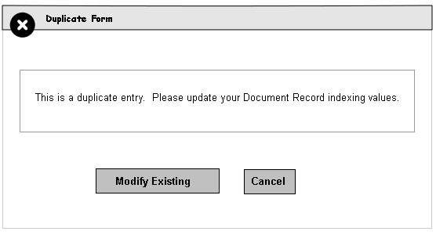

Fig: 2.b – Duplicate Entry Alert

## Modify Form

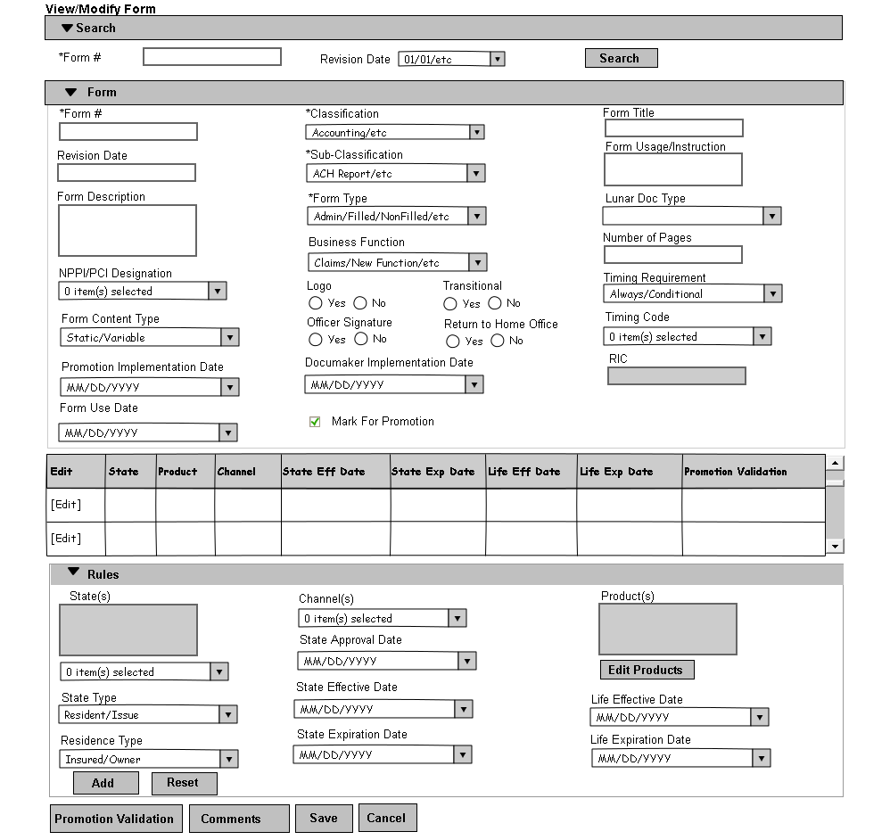

Fig: 2.c - View/Modify Form

1. Modify Form Screen Functionality  
   * + 1. After performing a search for Form # (and Revision Date) in Modify Form screen search section (Fig: 2.c), the Form Information is displayed for view/modify.
       2. System shall perform exact case insensitive search for user entered Form # and/or Revision Date.
       3. Clicking on Revision Date drop down after entering Form # shall bring the related revision date(s) for entered Form #. Any change to Form # shall disable Revision Date drop down momentarily and on focus of revision date shall re-fetch revision date for changed Form #.
       4. If the Form is part of any In-Progress release group Save button shall be disabled and an alert message displayed for user to Modify this Form from Edit Release Group screen (Section 6.2.2) (Fig: 2.d).
       5. All the buttons shall be disabled if the revision date is not latest. User shall view the form for any revision date(s) and modify Form for latest revision date.
       6. Clicking on Comments button shall open comments screen. (Section 1.10 View/Add Comments)
       7. Clicking Save shall run validations against this screen and save modified Form information if validations are pass. If any validation fails, the error will be displayed.
       8. Clicking cancel will invoke Unsaved Changes functionality (Sec 1.9 Unsaved Changes).
       9. New RIC shall be created with same information except History and comments after validation for Form when the user change Form #/Revision Date (Clone Form).
       10. If the Form # and Revision Date combination already exists system shall invoke Duplicate Form alert (Please refer section 2.1.3 Duplicate Form.)
       11. System shall expire previous version of the same Form when Expiration Date is max date and Marked For Promotion when the user changed Revision Date only.
       12. Fields denoted with an ‘*’ are required.
       13. All the other functionalities are same with Create Form screen. (Please refer section 2.1.2 Form Screen Fields, 1.8 Products Screen, 1.9 Unsaved Changes and 2.1.3 Duplicate Form)

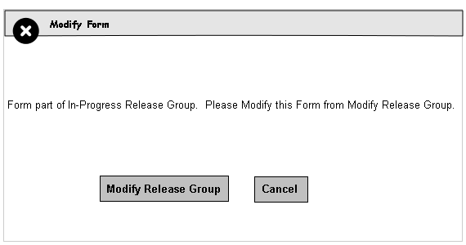  
 Fig: 2.d Form Part of In-Progress Release Group alert



















# Create/Modify Record

The main navigation Records tab is where all functions related to Record is performed. From this tab user can create new record and modify existing record. (Modify Record link).  
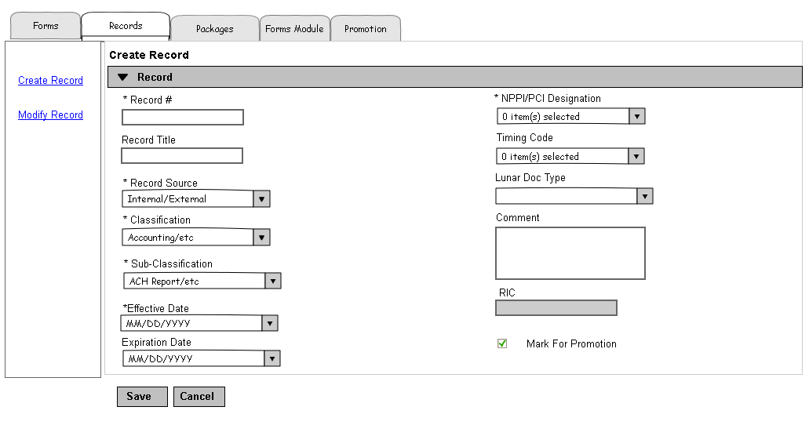

Fig: 3.a – Record Home/Create Record Screen.

## Create Record

* + - 1. Create Record Screen Functionality  
         1. If values are selected from the Classification drop-down, the Sub-Classification values shall be filtered based on the Classification values. If values are selected from the Sub-Classification drop-down prior to choosing values in the Classification drop-down, values in the Classification drop-down shall be filtered based on the Sub-Classification values chosen.
         2. If N/A is selected in NPPI/PCI designation no other options can be selected. If values other than N/A are selected, N/A cannot be selected.
         3. Clicking Save shall run validations against this screen and save Record information if validations are pass. If any validation fails, the error shall be displayed as noted in section 1.1.1.1.
         4. If the Record # already exists system shall invoke Duplicate Record alert (Please refer section 3.1.4 Duplicate Record.)
         5. Clicking cancel shall invoke Unsaved Changes functionality (Sec 1.9 Unsaved Changes)
         6. Fields denoted with an ‘*’ are required.
      2. Record Screen Fields.

| **Screen Label** | **Required for Shell** | **Other Information** | **Required for Promotion** |
| --- | --- | --- | --- |
| Record Source | M | Values:   * Internal * External | M |
| Classification | M | Single-select  See: Unique Forms Spreadsheet (CR 409) | M |
| Sub-classification | M | Single-select  See: Unique Forms Spreadsheet (CR 409) | M |
| Timing Code (CR 459) | O | Values:   * POS * Delivery * In Process * Post Issue * Claims * Reg 60 Stage 1 (CR 459) * Reg 60 State 2 (CR 459) | O |
| Record Title | O (CR621) (CR 504) | Length: 100 Field Type: ANSC | O (CR621) (CR 504 ) |
| Record # | M (CR 192) (CR 504) | Length: 100 Field Type: ANSC | M (CR 192) (CR 504) |
| Lunar Doc Type | O (CR621) | Single-select  Values will be maintained by RDM | O (CR621) |
| NPPI/PCI Designation | M | Values:   * N/A * Informational * Personal * Financial * Medical | M |
| Effective Date | M | Format:mm/dd/yyyy | M |
| Expiration Date | O | Format:mm/dd/yyyy | O |
| RIC | AP | Length : 10  Numeric | M |
| Comment | O | Length: 1000 Field Type: ANSC | O |

* + - 1. Classification and Sub-Classification

Only those classifications (Values will be maintained by RDM) that are related to sub-classifications with a sub-classification usage type of ‘All’ or ‘Indexing’ shall display in the list of available classifications for Records.

Only those sub-classifications (Values will be maintained by RDM) (CR 409) with a sub-classification usage type ‘All’ or ‘Indexing’ shall display in the list of available sub-classifications for Records.

* + - 1. Duplicate Record
         1. The system shall determine if a newly created Record Indexing Classification is a duplicate entry by comparing the Record #.
         2. If the record # matches with existing record, the system shall display the following alert message: ‘This is a duplicate entry. Please update your Document Record indexing values.’ (Fig 3.b)
         3. Clicking Cancel shall return the user to the Create Record screen where they can modify ‘Record #’ and re-save. Clicking Cancel again on the Create Record screen shall discard changes (a pop-up will be displayed informing the user they have unsaved changes).
         4. Clicking Modify Existing shall discard any changes the user made to the existing information, return the user to Modify Record screen where the existing Record information shall be displayed.

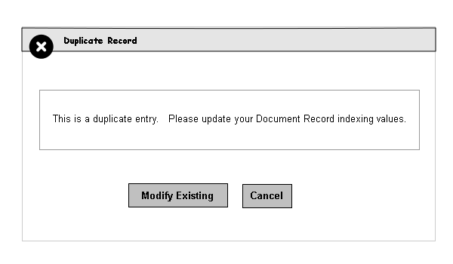  
 Fig: 3.b – Duplicate Record

## Modify Record

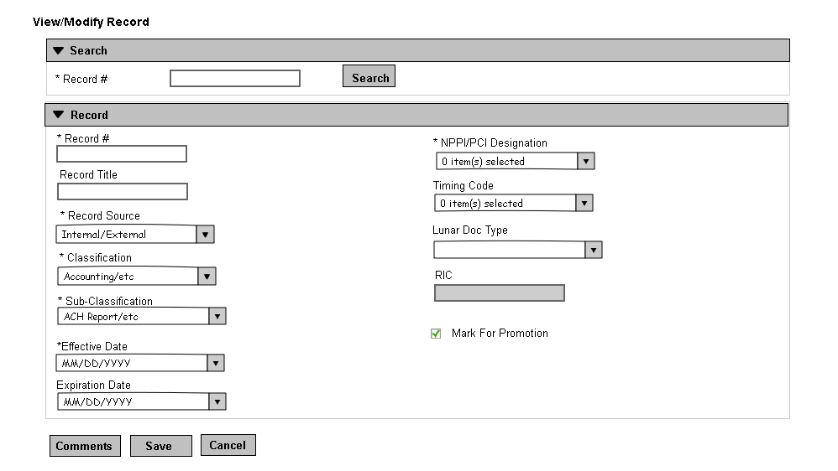

Fig: 3.c - View/Modify Record Screen

1. Modify Record Screen Functionality
   * 1. After performing a search for Record # in Modify Record screen (Fig: 3.c), the Record Information is displayed for modify.
     2. System shall perform exact case insensitive search for user entered Record #.
     3. If the Record is part of any In-Progress release group Save button shall be disabled and an alert message shall be displayed for user to Modify this record from Edit Release Group screen (Sec 6.2.2) (Fig: 3.d).
     4. New RIC shall be created after validation for record when the user change Record # (Clone). If the record # already exists in the system user shall get Duplicate Record # error message (Fig: 3.b.)
     5. Clicking Save shall run validations against this screen and save modified Record information if validations pass. If any validation fails, the error shall be displayed as noted in section 1.1.1.1.
     6. Clicking Cancel shall invoke Unsaved Changes functionality (Sec 1.9 Unsaved Changes)
     7. Fields denoted with an ‘*’ are required.
     8. All the other functionalities are same with Create Record screen. (Please refer section 2.1.1.1 Record Screen Fields, 1.9 Unsaved Changes, 2.2.1 Classification and Sub Classification and 2.3.1 Duplicate Record Number)

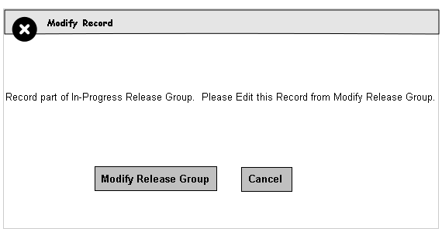  
 Fig: 3.d - Record Part of In-Progress Release Group alert

# Create/Modify Package

The main navigation Packages tab is where all functions related to Package is performed. From this tab user can create new Package and modify existing Package. (Modify Package link).

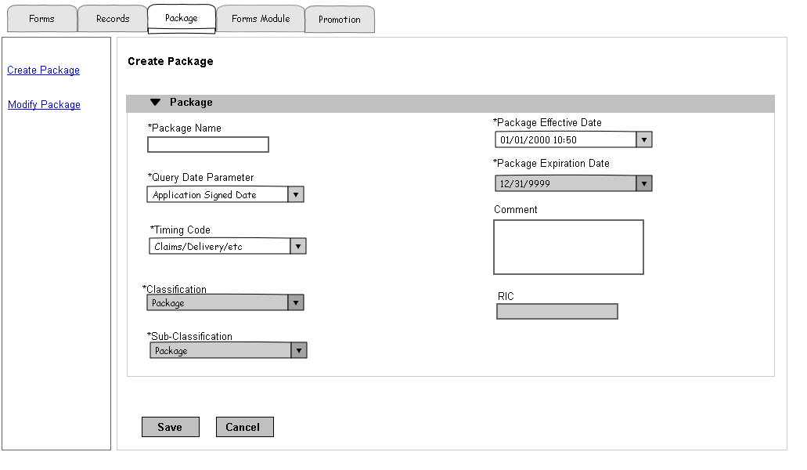

Fig - 4.a Packages Home/Create Package

## Create Package

* + - 1. Create Package Screen Functionality  
         1. User shall enter Package Name, Query Date Parameter, Package Effective Date, Timing Code (CR 878) and Initial comment.
         2. Classification and Sub-Classification for Package shall default to Package.
         3. User shall get “Invalid Effective Date” error message if Package Effective Date is not a valid date.
         4. Clicking save shall create new Package, timing code and initial package version with same Package Effective Date and Package Expiration Date if validations pass.
         5. User shall get Duplicate Package Name error if the package name matches with existing Package Name. (Section 4.1.3 Duplicate Package use case)
         6. Clicking Cancel shall cancel create package and discard any information entered.
         7. Fields denoted with an ‘*’ are required.























* + - 1. Create Package Screen Fields

| **Screen Label** | **Required** | **Other Information** |
| --- | --- | --- |
| Package Name | M (CR 504) | Length: 100 Field Type: ANSC |
| Classification | M(CR 357) | Non Editable  Default: Package |
| Sub-Classification | M(CR 357) | Non Editable  Default: Package |
| Package Effective Date | M | Format: mm/dd/yyyy hh:mm  Default: Current Date |
| Package Expiration Date | M | Non Editable  Default: 12/31/9999 |
| RIC | AP | Length:10 Non Editable  Numeric |
| Query Date parameter | M | Single-select Values:   * Request Date * Application Signed Date * Contract Effective Date * Stage 1 Paperwork Signed Date |
| Mark For Promotion | O | Checkbox |
| Timing Code | M (CR 878) | Single-select Values:   * POS * Delivery * In Process * Post Issue * Claims * Reg 60 Stage 1 (CR 459) * Reg 60 Stage2 (CR 459) |
| Comment | O | Length: 100 Field Type: ANSC |

* + - 1. Duplicate Package
         1. The system shall determine if a newly created Record Indexing Classification is a duplicate entry by comparing the Package Name.
         2. If the Package Name matches with Existing Package, the system shall display the following alert message: ‘The Package Name already exists. Please update the Package Name or discard the package.’ (Fig 4.b)
         3. Clicking Cancel shall return the user to the Create Package screen where user can modify ‘Package Name’ and re-save. Clicking Cancel again on the Create Package screen shall discard changes (a pop-up will be displayed informing the user they have unsaved changes).
         4. Clicking Modify Existing shall discard any changes the user made to the existing information, return the user to the Modify Package screen where the existing Package information shall be displayed.

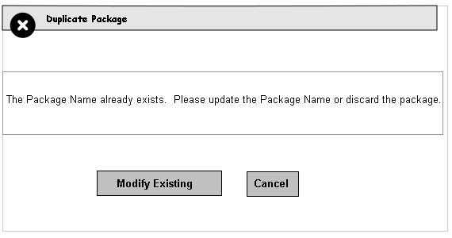  
 Fig - 4.b Duplicate Package

## Modify Package

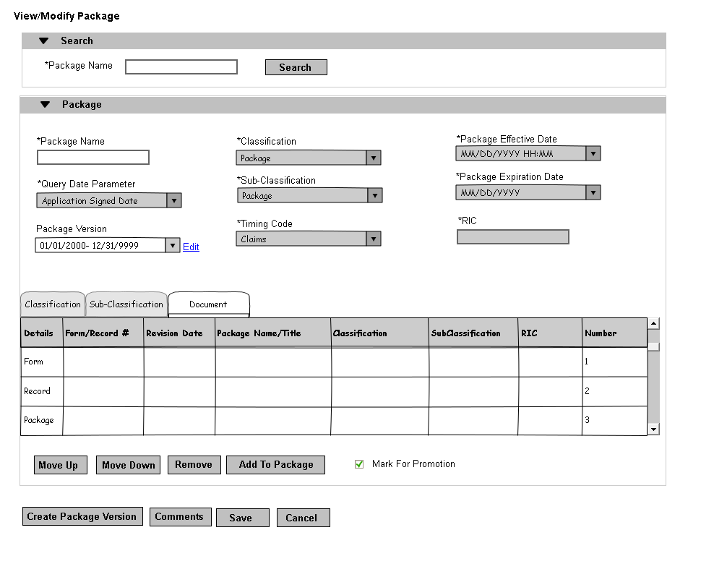

Fig 4.c - Modify Package Screen

* + - 1. Modify Package Screen Functionality
         1. System shall autofill matching package names when user start typing package name under Search Package Name (Fig: 4.c).
         2. User entered Package Name shall exactly match with System Package Name. The match shall not be case sensitive.
         3. Clicking on Search button with Package name shall bring Package Information for modify with the latest version selected.
         4. Clicking on Add To Package button shall take the user to Add To Package screen.(Section 4.2.4. Add To Package)
         5. User shall add Forms/Records/Packages matching with Package Timing Code and Effective date spans within Package Version Effective Date and Expiration Date.
         6. Move Up, Move Down, Remove and Add To Package button shall be enabled only when the selected version is latest version and Not Marked for Promotion.
         7. User cannot modify any previous Package Versions that are already promoted.
         8. User cannot modify the latest package version marked for promotion but not yet promoted when they navigate directly from Modify Package screen.
         9. User has to navigate from Edit Release Group (Sec 6.2.2) If they want to modify (add/remove Forms/Records/Packages) the latest Package Version that is marked for promotion but not yet promoted.
         10. Clicking on Move Up or Move Down button after selecting any Form/Record/Package from Document table shall Move Up or Down the order. The Document table shall refresh and show new order.
         11. Clicking on Remove after selecting any Form/Record/Package from Document table shall remove it from Package Version. The document table shall refresh and show new order.
         12. Clicking on Comments button shall open comments screen. (Section 1.10 View/Add Comments)
         13. User shall create new/In-Progress package version by clicking on Create Package Version button. Create Package Version button shall enable only when the latest version is marked for Promotion or already promoted. The system allows the user to create only one In-Progress Package version per Package at a time/till it is Marked for Promotion. (Section 4.2.6 Create/Modify Package Version)
         14. Checking on Mark For Promotion check box shall set the latest version’s Expiration date one day earlier to In-Progress version’s Effective Date (if any) and Mark latest and In-Progress (if any) version(s) for promotion. This button shall enable only when the system has In-Progress Package version available or latest version is not Marked for Promotion. After final save In-Progress version (if any) becomes latest version.
         15. New RIC shall be created after validation for Package when the user change Package Name (Clone). If the Package Name already exists system shall invoke Duplicate Package Name alert (Section 4.1.3. Duplicate Package)
         16. Save button shall be disabled when the latest version is Marked for Promotion.
         17. Clicking on Save button shall save Package Version changes for rules 4.2.1.4 to 4.2.1.14.
         18. Clicking on Cancel button shall invoke Unsaved Changes functionality (Section 1.9 Unsaved Changes)
      2. Classfication Tab
         1. For Classification tab (Fig: 4.c), the main list view shall show a summary list of contiguous Classifications for the actual Document list.
         2. If a Classification is broken up non-contiguously, it shall appear in the list multiple times showing both groupings of Documents in the order which they appear. Selecting a particular Classification in the list and clicking on a button below will affect all of the Documents in that grouping.
         3. Clicking on “Move Up” button, would move all the contiguous Documents for that Classification up above the Classification displayed above it.
         4. Clicking on “Move Down” button would move the selected Classification down below the one immediately following it.
         5. Clicking on “Remove” button would remove the selected Classification from the Package Iteration entirely.
         6. Clicking on “Add To Package” button shall take the user to Add To Package screen.(Section 4.2.4. Add To Package)
         7. Whatever Classification is input from that screen will be added above the selected Classification group from this screen. If no selection has been made, it will be placed at the bottom of the listing.
      3. Sub-Classfication Tab
         1. For Sub-Classification tab (Fig: 4.c), the main list view shall show a summary list of contiguous Sub-Classifications (along with their parent Classifications) for the actual Document list.
         2. If a Sub-Classification is broken up non-contiguously, it shall appear in the list multiple times showing both groupings of Documents in the order which they appear. Selecting a particular Sub-Classification in the list and clicking on a button below will affect all of the Documents in that grouping.
         3. Clicking on “Move Up” button, would move all the contiguous Documents for that Sub-Classification up above the Sub-Classification displayed above it.
         4. Clicking on “Move Down” button would move the selected Sub-Classification down below the one immediately following it.
         5. Clicking on “Remove” button would remove the selected Sub-Classification from the Package Iteration entirely.
         6. Clicking on “Add To Package” button shall take the user to Add To Package screen.(Section 4.2.4. Add To Package)
         7. Whatever Sub-Classification is input from that screen will be added above the selected Sub-Classification group from this screen. If no selection has been made, it will be placed at the bottom of the listing.
      4. Add To Package
         1. Default Add to Package screen shall be empty with no search results. (Fig 4.d)
         2. After performing search from Add to Package search for Form/Record #, Revision Date, Package Name, Form/Record Title, Classification and Sub-Classification (Fig 4.c) user shall select Forms/Records/Packages to add to the Package.
         3. Revision Date is only available for Forms. Form # without Revision Date shall bring all Forms with same Form #.
         4. The system shall perform wild card query search for any of the search criteria and bring results that is matching with Package Timing Code. User shall not need to enter any wild card characters while search.
         5. User shall select any Query Date Exception drop down value for selected Forms/Records/Packages.
         6. Clicking Add shall add the selected Forms/Records/Packages to selected Package Version.
         7. Clicking Cancel shall invoke Unsaved Changes functionality (Sec 1.9 Unsaved Changes)

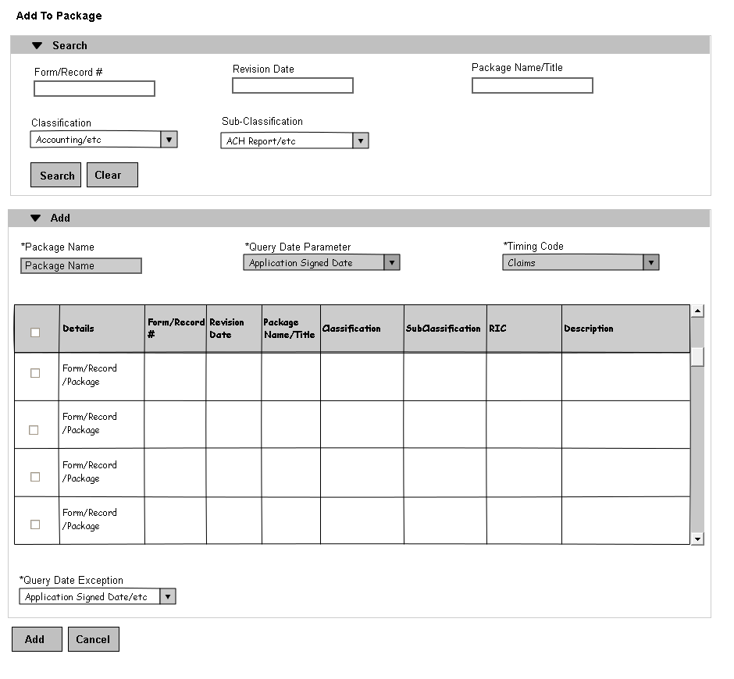

Fig 4.d – Add To Package Screen

* + - 1. Add To Package Screen Fields

| **Screen Label** | **Required** | **Other Information** |
| --- | --- | --- |
| Form/Record # | O | Length: 100 Field Type: ANSC |
| Revision Date | O | For Forms only Format: mm/yy |
| Package Name/Title | O | Package Name or Form Title or Record Title |
| Classification | O | Single-select |
| Sub-Classification | O | Single-select |
| Query Date Exception | M | Single-select |

* + - 1. Create/Modify Package Version
         1. Clicking on ‘Create Package Version’ button (Fig 4.c) shall Create New Package Version.
         2. Clicking on ‘Edit’ (Fig 4.c) link shall modify existing package version Effective Date.
         3. User shall select Package Version Effective Date greater than Package Effective Date and last Package version Effective Date (Fig 4.d).
         4. Clicking on Save shall create New Package Version with all the Forms/Records/Packages from last Package Version for Create Package Version (Step 4.2.6.1).
         5. Clicking on Save shall modify In-Progress Package Version Effective Date for Modify Package Version(Step 4.2.6.2).

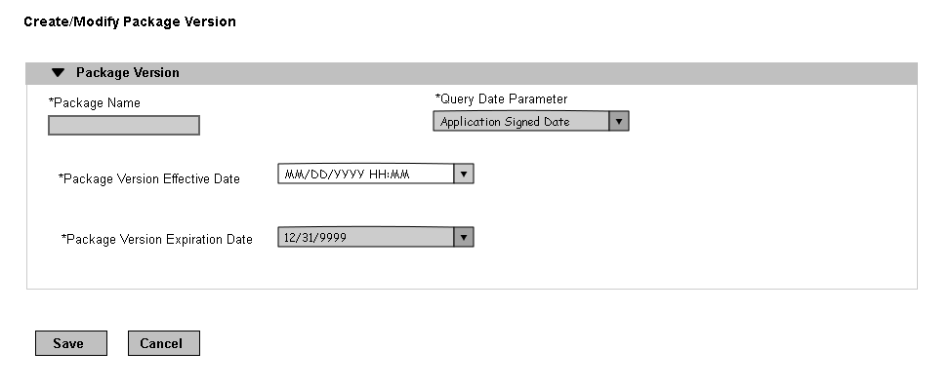  
 Fig 4.d Create/Modify Package Version















































# Create/Modify Forms Module Entry

The main navigation Packages tab is where all functions related to Forms Module Entry is performed. From this tab user can create new Forms Module Entry and modify existing Forms Module Entry. (Modify Forms Module Entry link).

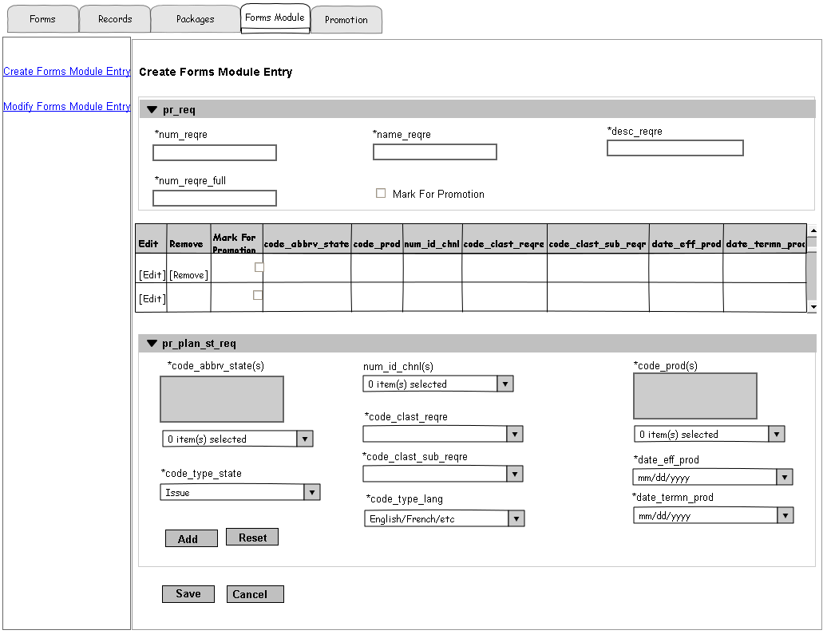

Fig - 5.a Forms Module Home/Create Forms Module Entry

## Create Forms Module Entry

* + 1. Create Forms Module Entry Screen Functionality
       1. Clicking Add button after selecting code_abbrv_state(s), num_id_chnl(s), code_prod(s) and other Rules section values shall add variation to pr_plan_st_req. User shall select multiple State, Product and Channel combinations with other values, but the table above represent them with single State, Product and Channel variation per row. Adding 2 States, 2 Products and 2 Channels represent 6 rows in the table.
       2. Clicking Add button shall populate variation(s) to the last row of the table after validation. Clicking save button shall save the changes permanent in database.
       3. Clicking Edit link in table shall bring the variation (State/Product/Channel) to pr_plan_st_req section for any changes. This shall discard any previous values in pr_plan_st_req section.
       4. Clicking Edit link in the table shall disable the Edit link to avoid multiple clicks on the same Edit link. Clicking on Add/Reset button after making any changes to variation in pr_plan_st_req section shall enable the Edit link.
       5. Clicking Remove link in table remove any invalid variation (State/Product/Channel) entered by user for pr_plan_st_req before save.
       6. Clicking States drop down allows the user to select multiple states. The total list of states should be 51 US states, including Washington DC.
       7. If any validation fails, the error shall be displayed as noted in section 1.1.1.1.
       8. Clicking Reset button shall clear and discard any partially entered values or variation selected.
       9. Checking Mark For Promotion checkbox at pr_req section shall mark the pr_req table values for Promotion.
       10. Checking Mark For Promotion checkbox at pr_plan_st_req section shall mark pr_plan_st_req table for Promotion.
       11. Fields denoted with an ‘*’ are required.
    2. Create Forms Module Entry Screen Fields

| **Screen Label** | **Required** | **Other Information** |
| --- | --- | --- |
| num_reqre | M (CR 504) | Length: 20 Field Type : ANSC |
| name_reqre | M | Length : 60 Field Type : ANSC |
| desc_reqre | M | Length : 30 Field Type : ANSC |
| num_reqre_full | M | Length : 100 Field Type : ANSC |
| code_abbrv_state(s) | M | Mutli-select |
| num_id_chnl(s) | O (CR 386) | Multi-select (All Channels – null, Personal Insurance-1, Bank -3, Independent – 4) |
| code_prod(s) | M | Multi-select |
| code_clast_reqre | M | Single-select (R- Requirements, P – Policy Forms, S- Special Requirements, F- Footnotes, A – Directly to Applicant, I – ePass Image)  Values will be maintained by RDM. |
| code_clast_sub_requre | M | Single-select Values will be maintained by RDM. |
| code_type_state | M | Single-select (Issue –I, Residence – R) |
| code_type_lang | M | Single-select (English –E, French – F) |
| date_eff_prod | M | Format: mm/dd/yyyy |
| date_termn_prod | M | Format: mm/dd/yyyy |
| Mark For Promotion | O | Checkbox |

* + 1. Duplicate Forms Module Entry
       1. The system shall determine if a newly created num_reqre is a duplicate entry by comparing the num_reqre column in pr_req.
       2. If the num_reqre matches with existing num_reqre, the system shall display the following alert message: ‘This is a duplicate entry. Please update your Form Module Entry Values.’ (Fig 5.b)
       3. Clicking Cancel shall return user to the Create Forms Module Entry screen where they can modify num_reqre and re-save. Clicking Cancel again on the Create Forms Module Entry screen will discard changes (a pop-up will be displayed informing the user they have unsaved changes).
       4. Clicking Modify Existing will discard any changes the user made to the existing information and return the user to the Modify Forms Module Entry screen where the existing Forms Module Entry information shall be displayed.

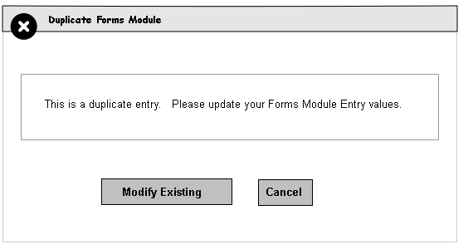  
 Fig 5.b Duplicate Forms Module Entry

## Modify Forms Module Entry

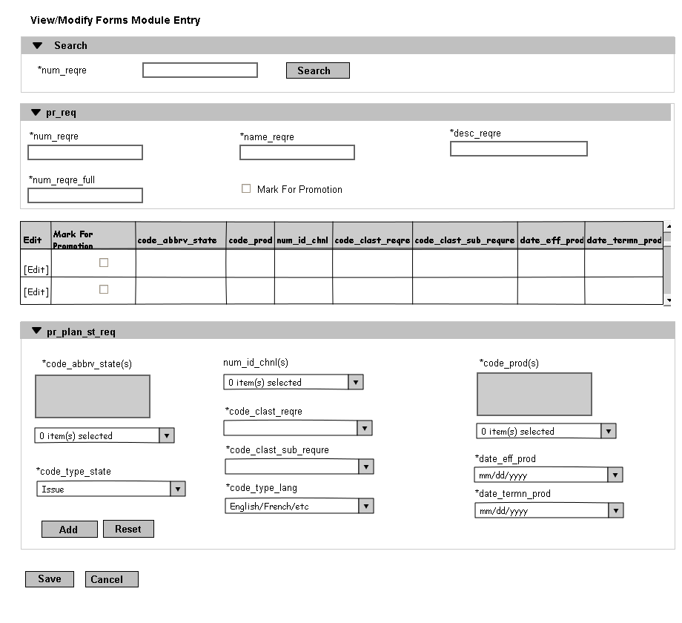

Fig 5.c Modify Forms Module Entry

* + 1. Modify Forms Module Entry Screen Functionality
       1. After performing a search for num_reqre in Modify Forms Module Entry screen search section (Fig: 5.c), the Forms Module Entry Information is displayed for modify.
       2. System shall perform exact case insensitive search for user entered num_reqre.
       3. User shall check ‘Mark For Promotion’ checkbox under pr_req section for promote only PR_REQ table Information.
       4. All pr_req fields except num_reqre shall be Read-only if pr_req is Marked For Promotion but not yet promoted.
       5. User shall check ‘Mark For Promotion’ checkbox in the table to promote any pr_plan_st_req values. User shall promote pr_req and pr_plan_st_req(s) separately.
       6. Edit link and Mark for Promotion check box shall be disabled if the pr_plan_st_req is Marked For Promotion but not yet promoted.
       7. New Forms Module Entry shall be created with all pr_req and pr_plan_st_req(s) information when user change num_reqre and save(clone). If num_reqre is already exists in the system user shall get Duplicate Forms Module Entry error message.(Fig 5.b)
       8. Clicking Save shall run validations against this screen and save modified Forms Module Entry information if validations pass.
       9. If any validation fails, the error shall be displayed as noted in section 1.1.1.1.
       10. Clicking cancel will invoke Unsaved Changes functionality (Sec 1.9 Unsaved Changes).
       11. Fields denoted with an ‘*’ are required.
       12. All the other functionalities are same with Create Forms Module Entry screen. (Please refer section 5.1.2 Forms Module Entry Screen Fields, 1.9 Unsaved Changes and 5.1.3 Duplicate Forms Module Entry)

# Promotion

The main navigation Promotion tab is where all functions related to Release Group is performed. From this tab user can create new Release Group, Modify/View existing Release Group. (Modify Release Group link).

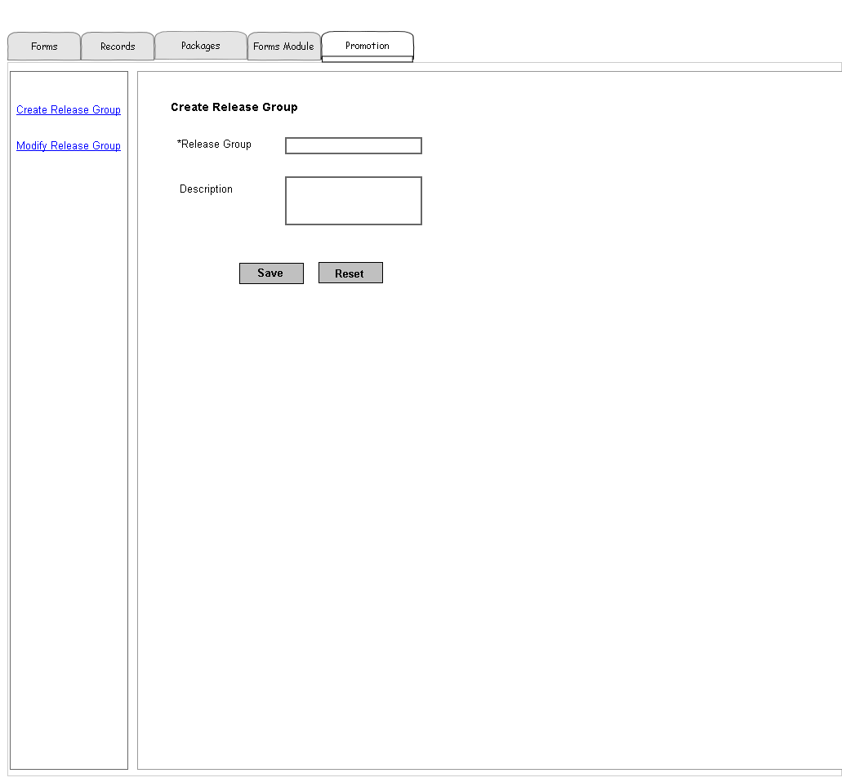  
 Fig - 6.a Promotion Tab/Create Release Group

## Create Release Group

* + 1. Create Release Group Screen Functionality
       1. The Create Release Group screen (Fig: 6.a) allows the user to enter a unique Release Group Name.
       2. The maximum length currently allowed for a Release Group Name is 80 characters.
       3. Clicking on the “Save” button shall validate the new Release Group Name is unique, and save the new name to the database and take user to the Modify Release Group screen (Fig: 6.c).
       4. If the entered name is not unique, an error dialog will be displayed with message “The Release Group Name entered is already in use. Please select a different Release Group.” (Fig: 6.b).
       5. Clicking on the Reset button shall discard anything in the Release Group field and Description field, but stay on the same screen to enter a new Release Group details.
       6. If any validation fails, the error shall be displayed as noted in section 1.1.1.1.

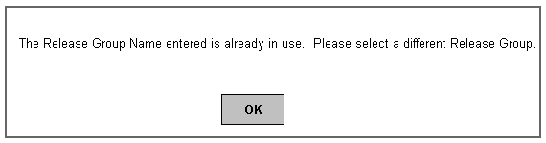

Fig: 6.b Duplicate Release Group Name Dialog

## Modify Release Group

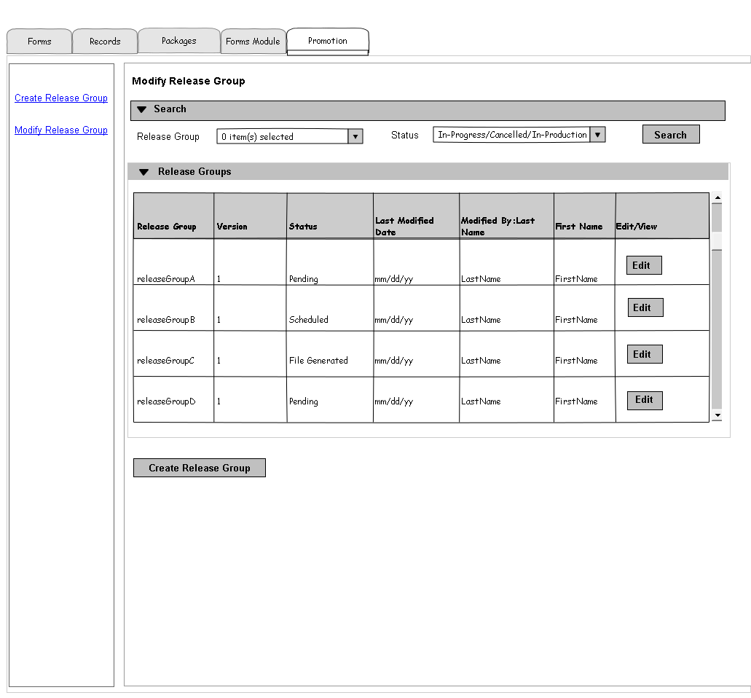

Fig: 6.c Modify Release Group

* + 1. Modify Release Group Screen Functionality
       1. After performing a search for Release Group Name/Status in Modify Release Group screen search section (Fig: 6.c), the Release Group Version Information is displayed for View/Edit.
       2. User shall select one or more Release Group name(s) from the Release Group Name multi-select drop down.
       3. Select ‘In-Progress’ status shall bring the Release Group versions in ‘Pending’, ‘Scheduled’, ‘Failed’, ‘File Generated’ and ‘Installed’ (Dev/QA/Test etc. except Production).
       4. Select ‘Cancelled’ or ‘In-Production’ status shall bring the Release Group versions were cancelled or deployed in Production.
       5. User shall see Edit button when they select ‘In-Progress’ status.(6.2.1.3)
       6. User shall see View button when they select ‘In-Production’ status.(6.2.1.4)
       7. User shall see disabled View button when they select ‘Cancelled’ status. (6.2.1.4)
       8. Clicking on “Edit” button shall take the user to Edit Release Group screen. (Sec 6.2.2 Edit Release Group)
       9. Clicking on “View” button shall take the user to Edit Release Group Screen with Read only permission. (Sec 6.2.2 Edit Release Group)
       10. Clicking on “Create Release Group” shall take the user to Create Release Group Screen (Sec 6.1 Create Release Group).
    2. Edit Release Group
       1. System shall group all the version(s) of Release Group in Edit Release Group screen, but default version selection is the version Edited by user from Modify Release Group Screen (Fig. 6.c)
       2. Everything is readonly for the Release Group that is deployed in Production. (Ie user can not modify the release group already deployed in Production.)
       3. User shall change the Versions drop down value to view different versions of same Release Group.
       4. User shall change the Release Group Name and click Save button any time before it deployed in Production. Changing Release Group Name for a version shall change the Release Group name for all the versions except version already deployed in Production.
       5. Enable checking on ‘Cancel Release Group Version’ shall cancel the Release Group after save.
       6. Clicking on Edit Form/Record/Package Version/Forms Module Entry type shall take the user to Modify Form/Modify Record/Modify Package/Modify Forms Module Entry screen where user can modify any time before the release Group deployed in Production.
       7. Clicking on Remove shall remove the Form/Record/Package Version/Forms Module Entry from the Release Group version.
       8. Clicking on Add Button shall take the user to Unassigned Documents screen. (sec 6.2.3 Unassigned Documents)
       9. Clicking on Save Button shall save the Release Group Version with added documents from the previous step.
       10. Clicking on Promote Button shall promote the Release Group Version after successful validation. Validation results shall display ‘Pass’/’Fail’ in Validation column (last). User shall fix any unsuccessful validation by Clicking on Edit button.
       11. User shall add document(s) (Step 6.2.2.7) to a release group after the latest release group version marked for promotion.
       12. Clicking save shall cancel latest release group version and create new version of Release Group with existing documents from latest release group and newly added documents. (after step 6.2.2.10)
       13. Clicking Cancel shall return user to Modify Release Group screen with previous search result. (Fig 6.c) Clicking cancel shall not roll back any changes made to Release Group version on step(s) 6.2.2.3 & 6.2.2.6.

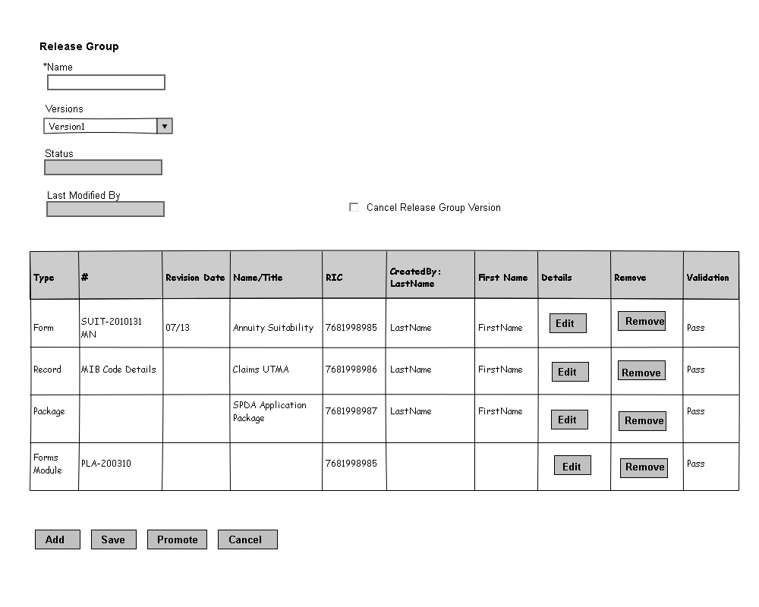  
 Fig: 6.d Edit Release Group

* + 1. Unassigned Documents
       1. User shall get this screen by clicking on Add Button from Edit Release Group (6.2.2).
       2. User shall select Forms/Records/Package Versions/Forms Module Entry from Unassigned documents screen.
       3. System shall show the Forms/Records/Package Versions/Forms Module Entry which are Marked for Promotion from their respective screens and not assigned to any Release Group which are In-Progress.
       4. Checking the check box to the respective documents select the documents to Add.
       5. Clicking Add button shall add the documents to the Release Group Version and redirect to Edit Release Group Version screen (Sec 6.2.2 Edit Release Group)
       6. Clicking Cancel button shall cancel any selected documents and redirect to Edit Release Group Version screen (Sec 6.2.2 Edit Release Group)

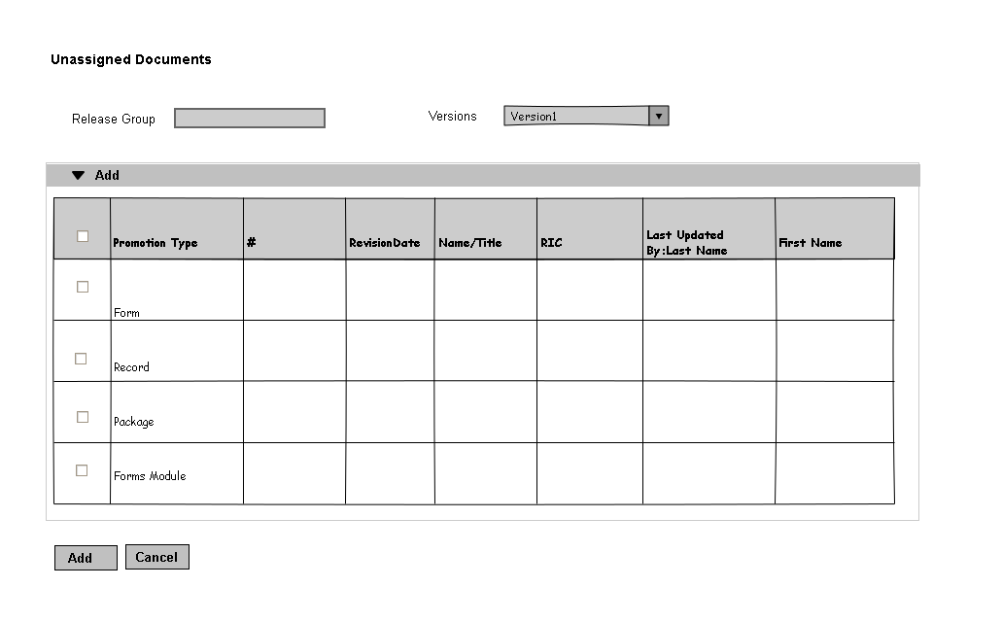   
 Fig: 6.e Unassigned Documents

* + 1. Modify Release Group For Release Group Manager
       1. Users with Release Group Manager site minder permission shall see Modify Release Group screen (Fig: 6.f).
       2. Functionalities are exactly same with Modify Release Group Regular Users.(Sec 6.2.1)
       3. Release Group Manager shall not have any other access permission in the screen except Edit button.
       4. Clicking on Edit button shall take the users to Edit Release Group Screen for Release Group Manager (Sec 6.2.5)
       5. Users with Release Group Manager permission shall not see Forms/Records/Packages/FormsModule tabs.

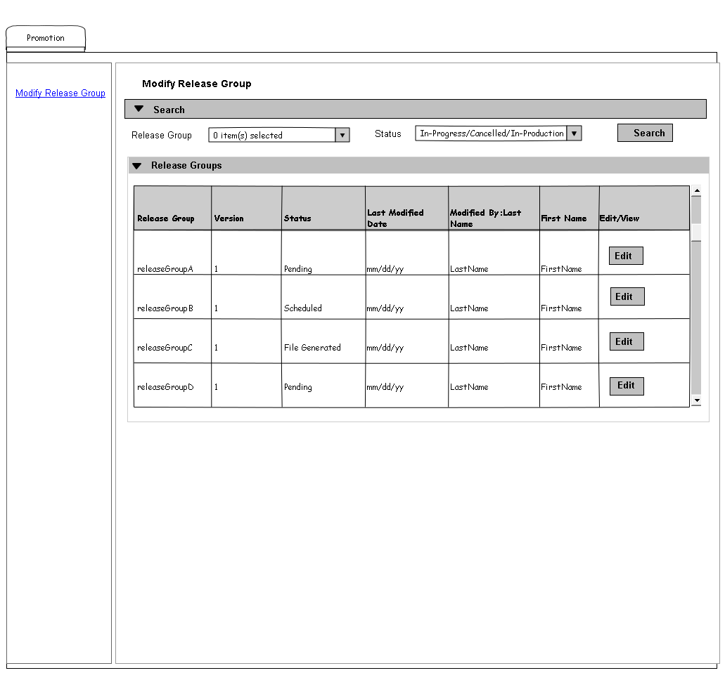

Fig: 6.f Modify Release Group For Release Group Manager

* + 1. Edit Release Group For Release Group Manager
       1. User shall get this screen by Clicking on Edit Button from Modify Release Group For Release Manager (6.2.4).
       2. User shall change the Environment drop down value and Click on Promote button to promote (scheduled) the Release Group version. (Fig 6.g)
       3. User shall not have accesss to any other buttons/functionalities in this screen.
       4. Informatica job shall generate file and install in to an environment when the release group environment is not empty and status is scheduled.
       5. User shall change the environment drop down and promote for each environment.

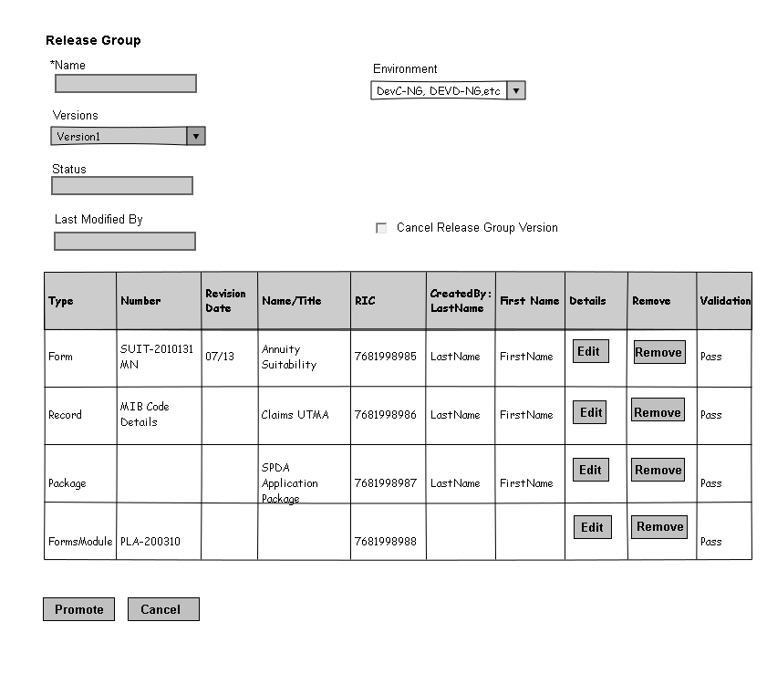  
 Fig: 6.g Edit Release Group for Release Group Manager

# Appendix

**Appendix A:**

Product Master Spreadsheet: <http://pmecollaborate.lmig.com/it/ilh/BAPGRM/Data%20Management/Product%20Master%20Hierarchy%20LifeWorks.xlsx> (CR 409)

**Appendix B:**

Formulator Extract Link:

<http://pmecollaborate/it/ilh/BAPGRM/Realease%202/Formulator%20Extract%20of%20Active%20Forms%203-4-2011.xls>

**Appendix C:**

[FRMS_Extract](http://pmecollaborate/it/ilh/BAPGRM/Realease%202/FRMS%20DAT%20Worksheet.xlsx):

[http://pmecollaborate.lmig.com/it/ilh/BAPGRM/Realease 2/FRMS_EXTRACT_Project Sync.xlsx](http://pmecollaborate.lmig.com/it/ilh/BAPGRM/Realease%202/FRMS_EXTRACT_Project%20Sync.xlsx)

**Appendix D:**

[Forms Module Requirements](http://pmecollaborate/it/ilh/BAPGRM/Realease%202/Forms%20Module%20Requirements.doc):

<http://pmecollaborate/it/ilh/BAPGRM/Realease%202/Forms%20Module%20Requirements.doc>

**Appendix E:**

Package Configuration:

<http://pmecollaborate.lmig.com/it/ilh/BAPGRM/Realease%202/R2%20Package%20Configuration%20Reference.xlsx>

Appendix F:

Package Trigger Rules:

http://pmecollaborate.lmig.com/it/ilh/BAPGRM/Realease%202/R2_I6_Packages%20and%20Trigger%20Rules%20v3.4.xlsx